Day 27 — Real-Time Banking Project

Create build.sbt—
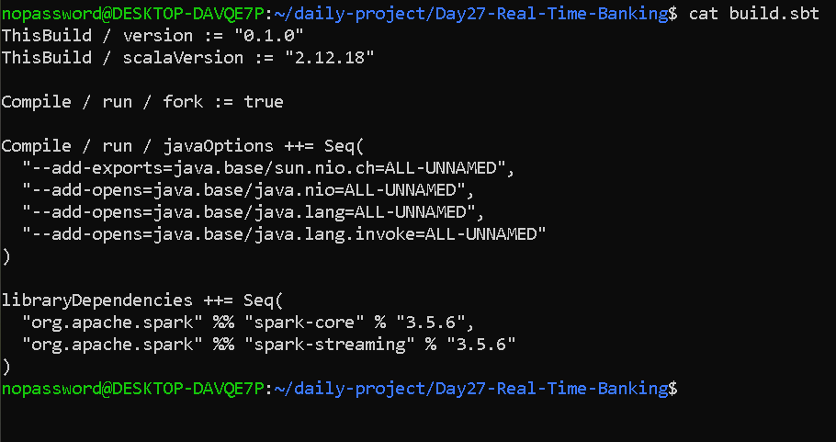

Create the SBT properties file—
nano project/build.properties
sbt.version=1.10.7

Create the banking application—
nano BankingMonitoring.scala

import org.apache.spark.SparkConf
import org.apache.spark.streaming._
import org.apache.spark.rdd.RDD

import scala.collection.mutable

case class Transaction(
transactionId: String,
accountId: String,
branchId: String,
amount: Double,
eventTime: String
)

case class BranchRisk(branchId: String, riskLevel: String)

object BankingMonitoring {

def main(args: Array[String]): Unit = {

val conf = new SparkConf()
.setAppName("Day27-Real-Time-Banking")
.setMaster("local[2]")
.set("spark.serializer",
"org.apache.spark.serializer.JavaSerializer")

val ssc = new StreamingContext(conf, Seconds(2))
ssc.sparkContext.setLogLevel("OFF")
ssc.checkpoint("./checkpoint")

// Small reference data: branch ID -> risk level
val branchRiskData = Map(
"B01" -> "LOW",
"B02" -> "MEDIUM",
"B03" -> "HIGH"
)

val branchRisk = ssc.sparkContext.broadcast(branchRiskData)

// Sample transactions, grouped into incoming batches
val batches = mutable.Queue(
ssc.sparkContext.parallelize(Seq(
Transaction("T001", "A101", "B01", 500.0, "10:00:01"),
Transaction("T002", "A101", "B01", 700.0, "10:00:02"),
Transaction("T003", "A202", "B02", 1500.0, "10:00:03")
)),
ssc.sparkContext.parallelize(Seq(
Transaction("T004", "A101", "B03", 12000.0, "10:00:04"),
Transaction("T005", "A101", "B03", 15000.0, "10:00:05"),
Transaction("T006", "A101", "B03", 18000.0, "10:00:06")
)),
ssc.sparkContext.parallelize(Seq(
Transaction("T007", "A202", "B02", 800.0, "10:00:07"),
Transaction("T008", "A303", "B01", 300.0, "10:00:08")
)),
ssc.sparkContext.parallelize(Seq(
Transaction("T009", "A101", "B03", 22000.0, "10:00:09"),
Transaction("T010", "A101", "B03", 25000.0, "10:00:10")
)),
ssc.sparkContext.emptyRDD[Transaction]()
)

val transactions = ssc.queueStream(batches, oneAtATime = true)

// Cache incoming transactions for reuse
val cachedTransactions = transactions.mapPartitions(
partition => partition
).cache()

// 1. Print transaction events and join with branch-risk reference data
cachedTransactions.foreachRDD { rdd =>
if (!rdd.isEmpty()) {
println("\n========== TRANSACTIONS ==========")

rdd.collect().foreach { tx =>
val risk = branchRisk.value.getOrElse(
tx.branchId, "UNKNOWN"
)

println(
s"[TRANSACTION] ID=${tx.transactionId}, " +
s"Account=${tx.accountId}, Branch=${tx.branchId}, " +
s"Amount=Rs.${tx.amount}, Risk=$risk"
)

if (tx.amount >= 10000 || risk == "HIGH") {
println(
s"[REVIEW] Transaction ${tx.transactionId} " +
s"requires review"
)
}
}
}
}

// 2. Aggregate transaction count and amount by account
val accountTotals = cachedTransactions
.map(tx => (tx.accountId, (1, tx.amount)))
.reduceByKey((a, b) =>
(a._1 + b._1, a._2 + b._2)
)

accountTotals.foreachRDD { rdd =>
if (!rdd.isEmpty()) {
println("\n========== ACCOUNT AGGREGATION ==========")
rdd.collect().foreach {
case (account, (count, total)) =>
println(
s"[ACCOUNT] $account | Transactions=$count | " +
f"Total=Rs.$total%.2f"
)
}
}
}

// 3. Detect suspicious bursts in a 10-second window,
// sliding every 4 seconds
val burstCounts = cachedTransactions
.map(tx => (tx.accountId, 1))
.reduceByKeyAndWindow(
(a: Int, b: Int) => a + b,
(a: Int, b: Int) => a - b,
Seconds(10),
Seconds(4)
)

burstCounts.foreachRDD { rdd =>
rdd.filter(_._2 >= 3).collect().foreach {
case (account, count) =>
println(
s"[BURST ALERT] Account=$account, " +
s"Transactions in window=$count"
)
}
}
// 4. Demonstrate partitioning on a batch RDD
ssc.sparkContext.parallelize(Seq(
("A101", 500.0),
("A202", 1500.0),
("A101", 12000.0),
("A303", 300.0)
), 2)
.keyBy(_._1)
.partitionBy(
new org.apache.spark.HashPartitioner(2)
)
.cache()
.foreachPartition { records =>
records.foreach { case (account, data) =>
println(
s"[PARTITION] Account=$account, " +
s"Amount=${data._2}"
)
}
}
println("Starting Real-Time Banking Monitoring...")
println("Window: 10 seconds | Slide: 4 seconds")

ssc.start()
ssc.awaitTerminationOrTimeout(16000)
ssc.stop(stopSparkContext = true, stopGracefully = true)

println("\nBanking Monitoring completed.")
}
}
Add log configuration—
nano log4j2.properties

status = error
name = BankingLogConfig
rootLogger.level = off

OUTPUT—

